How to set DMZ host for my Dual-band Gigabit Router
Product line: wireless question category: function config

Q: When do we need to configure DMZ host:
A：
1. Do not know the port number of some kinds of application servers, and then can’t set port mapping. Such as network cameras, some database software, etc., then you can open the DMZ host.
2.Can’t play some games when the normal operation (e.g. StarCraft) and you can land normally, but can’t field a team, then you can open the DMZ host.
3. Some special sites can not open or can’t operate normally, such as certain online banking can’t be transferred, can‘t enter the verification code, etc., and you can also try to open the DMZ host.
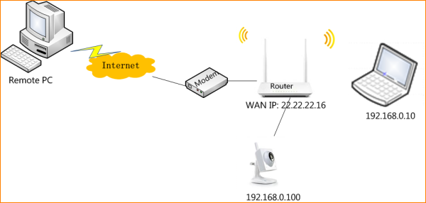
The steps are as below
- Connect your IP Camera to the router.
- Login to the management page of the router.
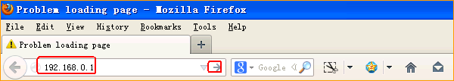
Input login username, password: admin, admin (default), to login, then click Advanced.
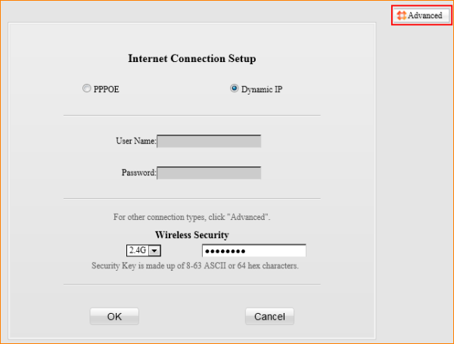
- Click Advanced, go to DMZ Host, then fill the IP Camera’s LAN IP192.168.0.100, tick Enable, then click Save.

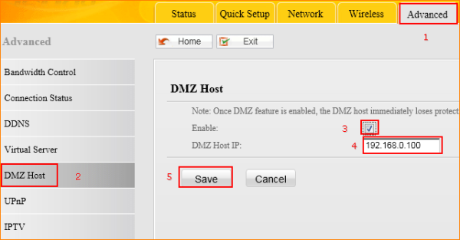

5.Reboot the router to active the settings.
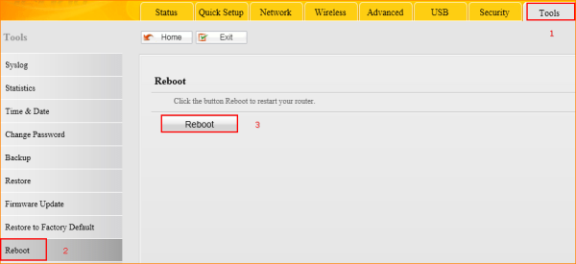
- Visit my IP Camera on the internet by typing ftp://22.22.22.16 (WAN IP of my router) in the address bar of the browser.
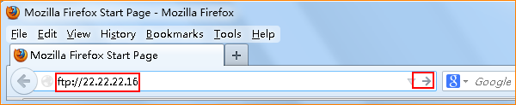
Tips: If your Internet Connection Type is PPPoE or DHCP, your WAN IP will change time to time, you’d better do DDNS settings to get a domain name for your WAN IP.

How to do DDNS settings on my router?

